Spin Transport Manipulation in Velocity Modulated
Graphene Structure

Mr. Chaiyawan Saipaopan M.Sc. (Physics for Teachers)

A Dissertation Submitted in Partial Fulfillment of the Requirements for
the Degree of Doctor of Philosophy (Physics)
Faculty of Science
King Mongkut’s University of Technology Thonburi
2019

Dissertation Committee


……………………………………………… Chairman of Dissertation Committee
(Assoc. Prof. Bumned Soodchomshom, Ph.D.)
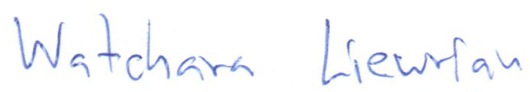

………………………………………………. Member and Dissertation Advisor
(Asst. Prof. Watchara Liewrian, Ph.D.)
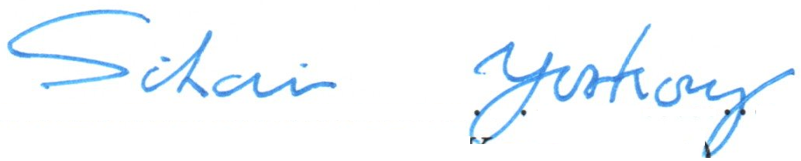

………………………………………………. Member
(Asst. Prof. Sikarin Yoo-Kong, Ph.D.)
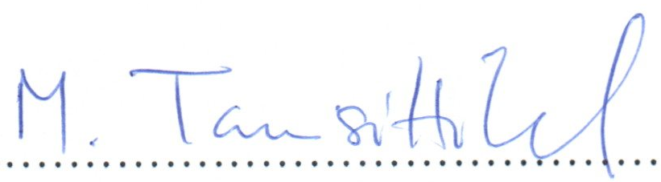

………………………………………………. Member
(Asst. Prof. Monsit Tanasittikosol, Ph.D.)
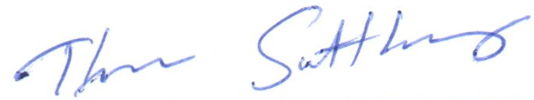

………………………………………………. Member
(Asst. Prof. Thana Sutthibutpong, Ph.D.)

Copyright reserved

